DWDM-1606
KAVINILAVU.S
192565038
ANALYTICAL PROBLEM-SOLVING ACTIVITY

Topic 1. Metrics for Performance Evaluation
1. Accuracy
A classification model tested 100 samples. It correctly classified 85 samples.
Questions:
- How many samples were classified incorrectly?
- Calculate the accuracy of the model.
- Calculate the error rate.
- Is the model performing well based on accuracy?
- What happens to accuracy if 5 more samples are classified correctly?
SOLUTION:
1. Accuracy
Given:
- Total samples = 100
- Correctly classified = 85
SOLUTION:
1. Accuracy
Given:
Total samples = 100
Correctly classified = 85
SOLUTION:

1. How many samples were classified incorrectly?
Incorrect=Total−Correct =100−85=15
Answer: 15 samples
2. Calculate the accuracy of the model.
Accuracy=Total Correctly Classified ×100 =100
85×100
Accuracy=85%
​

3. Calculate the error rate.
Error Rate=Total Incorrectly Classified ×100 =100
15×100
Error Rate=15%
4. Is the model performing well based on accuracy?
Yes. The model has an accuracy of 85%, meaning it correctly classifies 85 out of every 100 samples.
Yes, the model is performing reasonably well.
5. What happens to accuracy if 5 more samples are classified correctly?
New correctly classified samples:
85+5=90
Assuming the total remains 100:
Accuracy=100
90×100
90%
​

Answer: Accuracy increases from 85% to 90%.

2. Confusion Matrix
A model gives the following results:
- True Positive (TP) = 40
- True Negative (TN) = 35
- False Positive (FP) = 10
- False Negative (FN) = 15
Questions:
- What is the total number of predictions?
- Calculate the accuracy.
- Calculate the error rate.
- Which value represents incorrectly predicted positive cases?
- Which value represents incorrectly predicted negative cases?

SOLUTION:
Given:
TP = 40
TN = 35
FP = 10
FN = 15
SOLUTION:
1. Total number of predictions
Total = TP + TN + FP + FN
= 40 + 35 + 10 + 15
= 100
Answer: 100 predictions

2. Accuracy
Accuracy = (TP + TN) / Total × 100
= (40 + 35) / 100 × 100
= 75/100 × 100
= 75%

3. Error Rate
Error Rate = (FP + FN) / Total × 100
= (10 + 15) / 100 × 100
= 25/100 × 100
= 25%

4. Incorrectly predicted positive cases
FP = 10
False Positive represents incorrectly predicted positive cases.
Answer: 10

5. Incorrectly predicted negative cases
FN = 15
False Negative represents incorrectly predicted negative cases.
Answer: 15

3. Precision and Recall
A disease prediction system produces:
- TP = 80
- FP = 20
- FN = 10
- TN = 90
Questions:
- Calculate Precision.
- Calculate Recall.
- Which metric tells us how many predicted positive cases were actually positive?
- Which metric tells us how many actual positive cases were correctly identified?
- Which metric is more important when missing a positive case is dangerous?

3. Precision and Recall
Given:
TP = 80
FP = 20
FN = 10
TN = 90

SOLUTION:
1. Calculate Precision
Precision = TP / (TP + FP) × 100
= 80 / (80 + 20) × 100
= 80 / 100 × 100
= 80%
Answer: 80%

2. Calculate Recall
Recall = TP / (TP + FN) × 100
= 80 / (80 + 10) × 100
= 80 / 90 × 100
= 88.89%
Answer: 88.89%

3. Which metric tells us how many predicted positive cases were actually positive?
Answer: Precision

4. Which metric tells us how many actual positive cases were correctly identified?
Answer: Recall

5. Which metric is more important when missing a positive case is dangerous?
Answer: Recall
Because recall helps identify as many actual positive cases as possible and reduces false negatives.
4. Compare Two Classifiers
Two classifiers are tested on the same dataset.
Metric | Classifier A | Classifier B
Accuracy | 90% | 85%
Precision | 80% | 95%
Recall | 70% | 90%
Questions:
- Which classifier has higher accuracy?
- Which classifier has higher precision?
- Which classifier has higher recall?
- Which classifier would you choose if detecting as many positive cases as possible is important?
- Give one reason why accuracy alone may not be enough.

Metric | Classifier A | Classifier B
Accuracy | 90% | 85%
Precision | 80% | 95%
Recall | 70% | 90%
SOLUTION:
1. Which classifier has higher accuracy?
Classifier A = 90%
Classifier B = 85%
Answer: Classifier A

2. Which classifier has higher precision?
Classifier A = 80%
Classifier B = 95%
Answer: Classifier B

3. Which classifier has higher recall?
Classifier A = 70%
Classifier B = 90%
Answer: Classifier B

4. Which classifier would you choose if detecting as many positive cases as possible is important?
Classifier B has higher recall (90%).
Answer: Classifier B

5. Give one reason why accuracy alone may not be enough.
Accuracy alone may not show how well the model identifies positive cases. Precision and recall give more detailed information.
Answer: Accuracy alone may hide poor performance on positive cases.

5. Analyze Model Performance
A classification model produces the following results:
- TP = 70
- TN = 80
- FP = 20
- FN = 30
Questions:
- Calculate accuracy.
- Calculate precision.
- Calculate recall.
- Calculate the error rate.
- Based on these values, identify one strength and one weakness of the model.
5. Analyze Model Performance
Given:
TP = 70
TN = 80
FP = 20
FN = 30
Total = 70 + 80 + 20 + 30 = 200
SOLUTION:
1. Calculate Accuracy
Accuracy = (TP + TN) / Total × 100
= (70 + 80) / 200 × 100
= 150 / 200 × 100
= 75%
Answer: 75%

2. Calculate Precision
Precision = TP / (TP + FP) × 100
= 70 / (70 + 20) × 100
= 70 / 90 × 100
= 77.78%
Answer: 77.78%

3. Calculate Recall
Recall = TP / (TP + FN) × 100
= 70 / (70 + 30) × 100
= 70 / 100 × 100
= 70%
Answer: 70%

4. Calculate Error Rate
Error Rate = (FP + FN) / Total × 100
= (20 + 30) / 200 × 100
= 50 / 200 × 100
= 25%
Answer: 25%

5. Identify one strength and one weakness of the model.
Strength: Precision is 77.78%, which means most predicted positive cases are actually positive.
Weakness: Recall is only 70%, meaning some actual positive cases are missed.
Answer:
Strength → Precision = 77.78%
Weakness → Recall = 70%

Topic 2. Prediction Algorithms
1. Simple Linear Prediction
A company's sales are predicted based on advertising expenditure.
Advertising Cost (₹) | Sales
10 | 20
20 | 40
30 | 60
40 | 80
Assume the relationship is linear.
Questions:
- Identify the relationship between advertising cost and sales.
- Predict sales when advertising cost is ₹50.
- What happens to sales when advertising cost increases by ₹10?
- Is this an example of classification or prediction?
- Why is a linear prediction algorithm suitable here?
Given:
Advertising Cost Sales
10 20
20 40
30 60
40 80
Notice:
Sales=2×Advertising
Therefore:
Q1. Relationship
Positive linear relationship.
As advertising cost increases, sales increase.
Q2. Sales when advertising = ₹50
Sales=2(50)
Sales = 100
Q3. Increase advertising by ₹10
Sales increases by:
2×10=20
Sales increases by 20 units.
Q4.This is prediction/regression, not classification.
Q5.Linear regression is suitable because the relationship between advertising cost and sales is approximately linear.
WEKA:

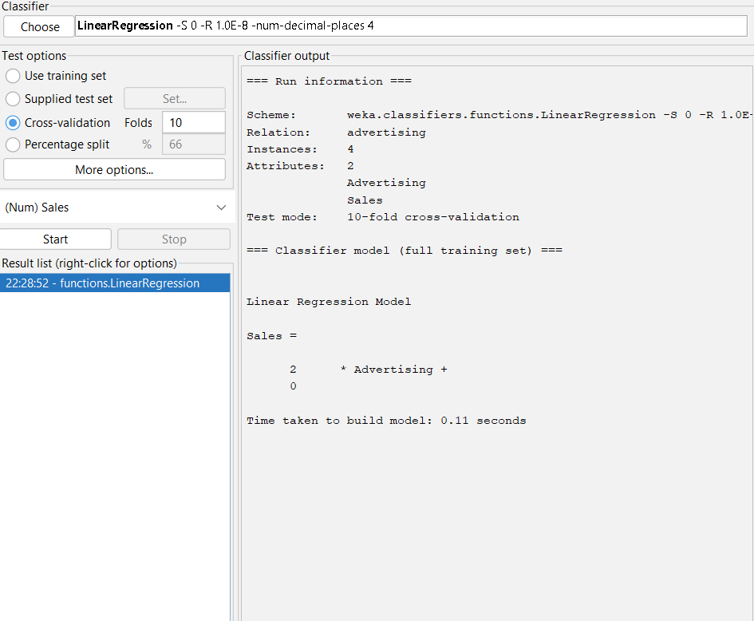

2. Predict Temperature
A simple prediction model is:
Day | Temperature (°C)
1 | 25
2 | 26
3 | 27
4 | 28
5 | ?
6 | ?
7 | ?
8 | ?
9 | ?
10 | ?
11 | ?
12 | ?
13 | ?
14 | ?
15 | ?

Questions:
- Predict the temperature on Day 5.
- Predict the temperature on Day 10.
- What is the predicted temperature on Day 15?
- How much does the temperature increase for every additional day?
- Is this a classification or prediction problem?
SOLUTION:
1. Predict the temperature on Day 5.
Answer: 29°C
2. Predict the temperature on Day 10.
Answer: 34°C
3. What is the predicted temperature on Day 15?
Answer: 39°C
4. How much does the temperature increase for every additional day?
From the data:
- Day 1 → 25°C
- Day 2 → 26°C
- Day 3 → 27°C
- Day 4 → 28°C
So the increase is:
1°C per day
5. Is this a classification or prediction problem?
Answer: Prediction (Regression)
Because the output is a numerical value (temperature in °C) rather than a category.
WEKA:
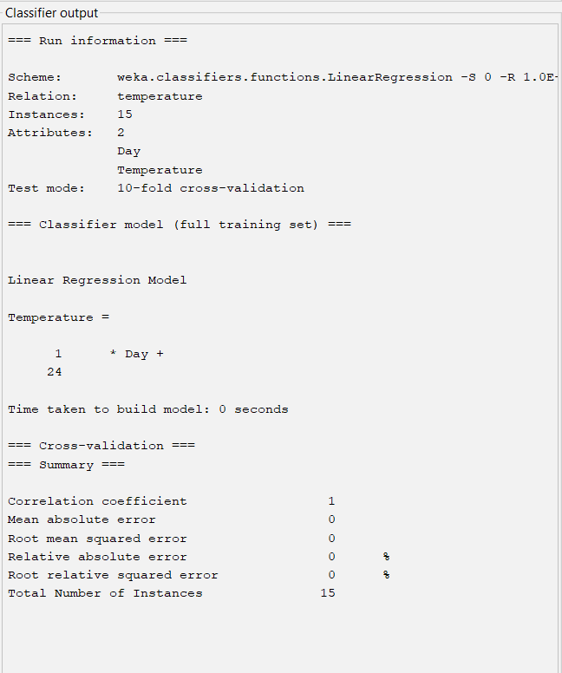
3. House Price Prediction
A prediction algorithm estimates house prices based on area.
Area (sq.ft) | Price (₹ lakhs)
1000 | 40
1500 | 60
2000 | 80
Assume a linear relationship.
Questions:
- Identify the relationship between area and price.
- Predict the price of a 2500 sq.ft house.
- What happens to the price when area increases by 500 sq.ft?
- Which type of algorithm can be used for this problem?
- Is this classification or numerical prediction?
Q4. Identify the relationship between area and price.

1.WEKA gives:
Price=0.04×Area
Therefore, there is a positive linear relationship between area and price.

2. Predict price for 2500 sq.ft
Use the WEKA equation:
Price=0.04(2500)
Price=100
Predicted price = ₹100 lakhs

3. What happens when area increases by 500 sq.ft?
From the coefficient 0.04:
500×0.04=20
Price increases by ₹20 lakhs.

4. Which algorithm?
In WEKA, you used:
LinearRegression
5.Classification or numerical prediction?
Numerical prediction / Regression
Because Price is a numerical value.

WEKA:
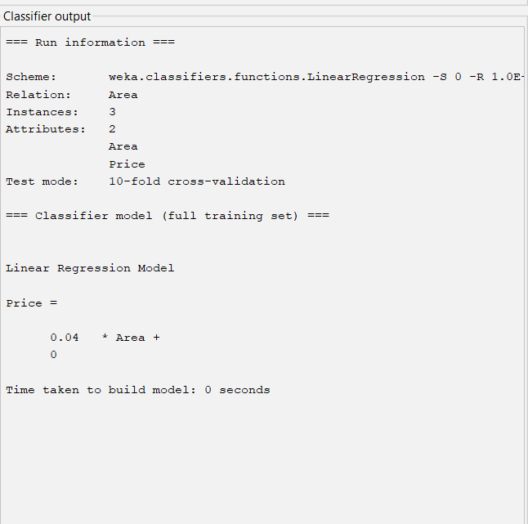

4. Compare Actual and Predicted Values
A prediction algorithm gives the following results:
Actual Value | Predicted Value
50 | 48
60 | 65
70 | 68
80 | 85
90 | 88
Questions:
- Which prediction has the smallest error?
- Which prediction has the largest error?
- Calculate the error for each prediction.
- Is the model generally predicting close to the actual values?
- Why is the difference between actual and predicted values important?
SOLUTION:
1. Which prediction has the smallest error?
The smallest error is 2.
It occurs for:
- 50 → 48
- 70 → 68
- 90 → 88
2. Which prediction has the largest error?
The largest error is 5.
It occurs for:
- 60 → 65
- 80 → 85
3. Error for each prediction:
2, 5, 2, 5, 2
4. Is the model generally predicting close to the actual values?
Yes. The prediction errors are small, ranging from 2 to 5 units.
5. Why is the difference between actual and predicted values important?
It shows how far the prediction is from the actual value and helps evaluate the accuracy/performance of the prediction model.

WEKA:
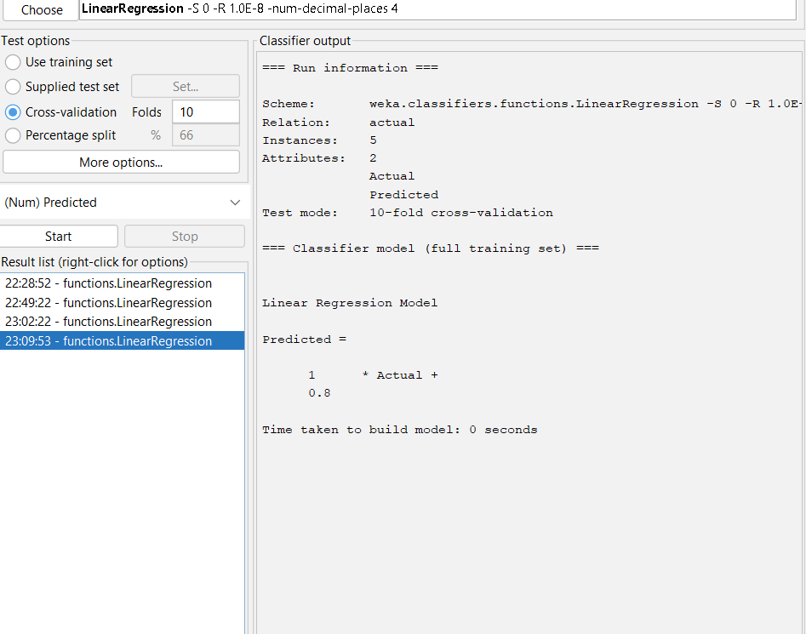

5. Choosing a Prediction Algorithm
Consider the following applications:
A. Predicting tomorrow's temperature.
B. Predicting the price of a house.
C. Predicting the number of products sold next month.
D. Predicting whether an email is spam or not.
Questions:
- Which applications are prediction problems?
- Which application is a classification problem?
- Which algorithm could be used for predicting house prices?
- Why is regression suitable for numerical prediction?
- Give one difference between classification and prediction.

SOLUTION:
1. Which applications are prediction problems?
The following are numerical prediction/regression problems:
- A. Predicting tomorrow's temperature → Prediction
- B. Predicting the price of a house → Prediction
- C. Predicting the number of products sold next month → Prediction
Answer: A, B and C

2. Which application is a classification problem?
D. Predicting whether an email is spam or not
The output is a category:
- Spam
- Not Spam
Answer: D

3. Which algorithm could be used for predicting house prices?
In WEKA, you can use:
Linear Regression
Path:
Explorer → Classify → Choose → functions → LinearRegression
Answer: Linear Regression

4. Why is regression suitable for numerical prediction?
Regression is suitable because it predicts continuous numerical values.
Examples:
- Temperature → 34°C
- House price → ₹100 lakhs
- Products sold → 500 units
Answer: Regression is suitable because it predicts numerical/continuous output values.

5. Give one difference between classification and prediction.
Classification | Prediction/Regression
Predicts a category/class | Predicts a numerical value
Example: Spam / Not Spam | Example: House price = ₹100 lakhs
Answer: Classification predicts a class/category, whereas regression predicts a numerical value.

